Problem 1:  
  
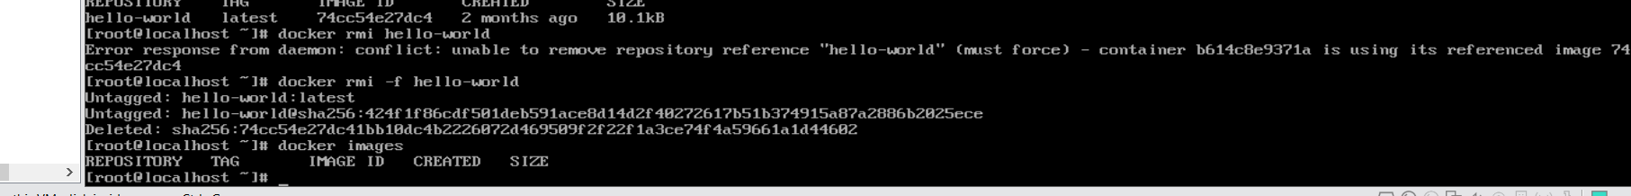  
  
problem 2:  
  


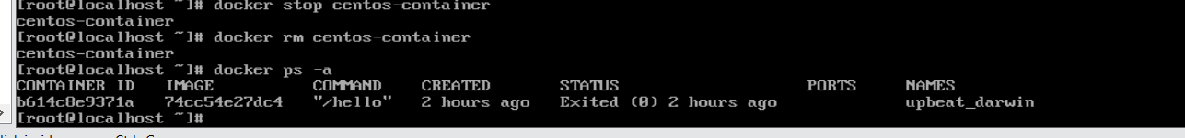



Problem 3:  
Created the volumes and pull the httpd to local

Attach the volumes to the container



Make sure that the container has been created

Remove the container and display all container to make sure it got deleted



Created another container and mapped the port 80 to 7800

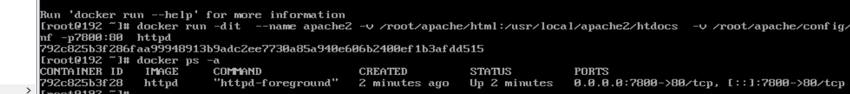

Access from the web page

Problem 4:  
Create the new container “apache3” without attach any volumes then copy the old index.html file from its path to the new contaciner.  
Created a new file called docker file and build the image from it.

Problem 5:

Created the volume “mysql” then created the container and let it run in the background and add the root password for MYSQL then pull the image, removed old containers

